7.8.24

Ex No:1 TOKENIZATION

**Program:**

#include<stdio.h>

#include<string.h>

intmain()

{ char option;

do{

char n;

printf("\n enter character:");

scanf(" %c",&n);

if(n>='A'&& n<='Z')

{

printf(" \n %c is a uppercase",n);}

else if(n>='a'&& n<='z')

{

printf(" \n %c is a lowercase",n);

}

else if(n>='0' && n<='9')

{

printf(" \n %c is a number",n);

}

else if(n=='+'||n=='-')

{

printf("\n %c is a arithmetic operator",n);

}

else if(n=='%'||n=='('||n==')'||n=='*')

{

printf("\n %c is a special character",n);

}

else if(n=='<'||n=='>')

{

printf("\n %c is relational operator",n);

}

else

{

printf("\n enter a valid character");

}

printf("\n do you want to continue:");

scanf(" %c",&option);

}while(option=='y');

return 0;

}

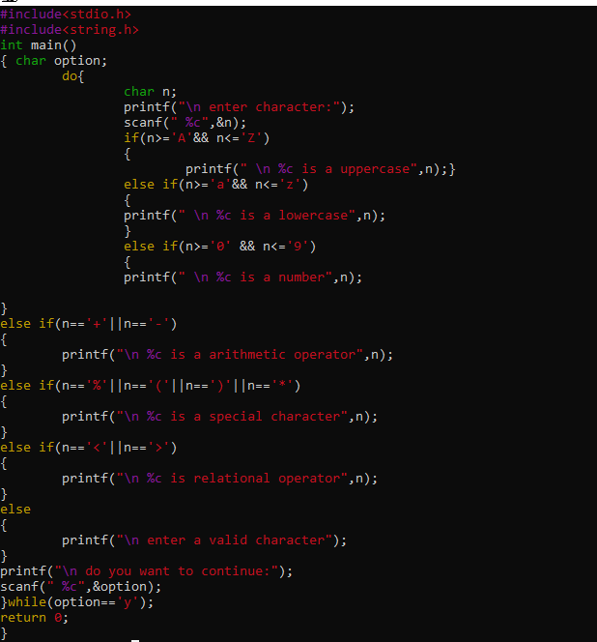

**Output:**

